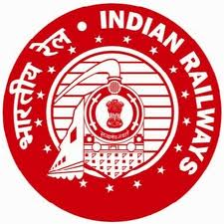

GOVERNMENT OF INDIA, MINISTRY OF RAILWAYS
RAILWAY RECRUITMENT BOARDS

IMPORTANT NOTICE
EXAM LANGUAGE
CEN 01/2018 (ALP & Technicians Posts)
Candidates may please note that they can choose any one of the language from the list 15 languages as exam language while taking the CBT irrespective of the language opted by them in the online application.

Chairpersons
Date: 03/
08/2018 Railway Recruitment Boards

